 | Analyzing data – tips, tricks  and experiences  Session 3 – reading files, indexing columns and rows,  using so-called logical expressions

General | This session deals with reading and writing to various types of files, using of indexing columns of columns and constants, and introduction to so-called logical expressions.
%DataInput | Perform the six exercises.
%DataStorage | A graph window explaining the various types of files used by Minitab.

Using the WOPEN- or the ODBC-command to enter data from a file

WOPEN is a command for entering data from different files. The two examples below shows the commands for reading a text file called WOPENDATA.DAT and an Excel file called WOPENDATA.XLS. Note that some commands for the DAT-file are not used when reading the Excel-file. The help function (MTB > HELP WOPEN) gives a full list of possible sub-commands.
The command OBDC (Open DataBase Connectivity) can also be used e.g. reading data from a database but also from a special tab of an Excel-file, see example below.

Reading a DAT-file | Comments | Reading an Excel-file
Wopen 'c:\Program Files\Minitab 15\macros\Programming\wopendata'; | The file name | Wopen 'c:\Program Files\Minitab 15\Macros\Programming\wopendata';
Ftype;  text; | The file type | Ftype;  Excel;
Field;  Comma; | Field separator
Variable 1;  Numeric; | 1st variable: numeric | Variable 1;  Numeric;
Variable 2;  Numeric; | 2nd variable: numeric | Variable 2;  Numeric;
Variable 3;  Numeric; | 3rd variable: numeric | Variable 3;  Numeric;
Variable 4;  Numeric; | 4th variable: numeric | Variable 4;  Numeric;
Variable 5;  Numeric; | 5th variable: numeric | Variable 5;  Numeric;
Variable 6;  text; | 6th variable: text | Variable 6;  text;
Tdelimiter;  Doubleqoute; | Textdelimiter
Vnames;  none. | no variables names | Vnames;  none.

Rows of data in ’c:\Program Files\Minitab 15\Macros\Programming\wopendata.dat’-file

951091882,31,9,809,7769,"SE2 ESEALNT567 EVO Srv Alvsjo",00:00:31
951091882,31,9,778,16399,"SE2 ESEALNT407 Mailbox srv Alvsjo",00:00:32
951091883,32,9,701,28149,"AM2 EAMBANT111 Mailbox Server Chile",00:01:19
951091883,32,9,817,1243,"AM1 EAMLYNT753 Mailbox Richardson",00:01:25
951091883,32,9,734,22142,"SE3 ESEKLNT110 Publ.F Fax Server Kumla",00:00:35
951091883,32,9,731,23429,"SE5 ESEGANT101 Mailbox Server Gavle",00:00:35
951091883,32,9,581,55632,"SE3 ESEKINT101 Mailbox Server Kista",00:00:41
951091883,32,9,700,31770,"SE2 ESEALNT128 Mailbox Server Alvsjo",00:00:37
951091883,32,9,707,30822,"SE5 ESEMONT031 Mailbox Server Molndal",00:00:36
951091883,32,9,691,34791,"SE2 ESEALNT181 Mailbox Server Alvsjo",00:00:37

Rows of data in ’c:\Program Files\Minitab 15\Macros\Programming\wopendata.xls’-file

951091883 | 32 | 9 | 707 | 30822 | SE5 ESEMONT031 Mailbox Server Molndal | 00:00:36
951091883 | 32 | 9 | 691 | 34791 | SE2 ESEALNT181 Mailbox Server Alvsjo | 00:00:37
951091883 | 32 | 9 | 696 | 32283 | SE2 ESEKINT287 Mailbox Server Kista | 00:00:38
951091883 | 32 | 9 | 820 | 1242 | SE3 ESEKLNT100 Publ.F Serv Kumla | 00:01:22
951091883 | 32 | 9 | 600 | 55248 | SE2 ESEALNT119 Connector B Kista | 00:00:41
951091884 | 33 | 9 | 597 | 56932 | SE0 ESEALNT141 X.400 Connector B Alvsjo | 00:00:42
951091884 | 33 | 9 | 591 | 55467 | SE4 ESEALNT117 Mailbox Server Alvsjo | 00:00:42
951091884 | 33 | 9 | 803 | 8202 | SE5 ESEALNT427 Mailbox Server Alvsjo | 00:00:42

Using the ODBC-command. To read a special tab of an Excel-file, the OBDC-command can be used. The command creates so-called SQL-commands. The following is an example and shows how to open the file 'c:\Program Files\Minitab 15\Macros\Programming\OBDC.xls':

Click [File]>[Query Database (OBDC)…] and the tab 'Machine Data Source'. This will open the following input field:

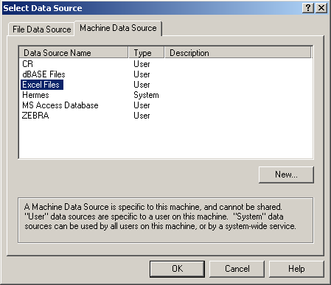 | The 'Data Source Name' Excel must be selected.  When clicking the OK-button, the particular file can be opened:  c:\Program Files\Minitab 15\macros\Programming\OBDC.xls

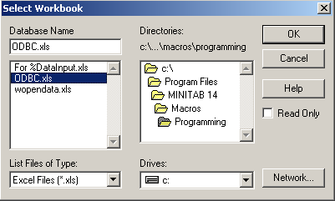
The tab to be opened

The columns to be read
This is the file to be opened

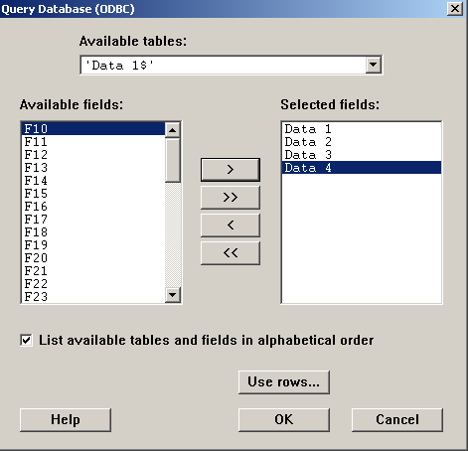
These commands are generated by Minitab and places the data in column c11-c14.

The columns to be read

ODBC;
Connect "DSN=Excel Files;DBQ=C:\Program Files\MINITAB 15\Macros\Programming" &
"\ODBC.xls;DefaultDir=C:\Program Files\MINITAB 15\Macros\Programming;Driver" &
"Id=790;MaxBufferSize=2048;PageTimeout=5;";
SQLString "SELECT `Data 1`,`Data 2`,`Data 3`,`Data 4` FROM `'Data 1$'`";
columns c11-c14.

Indexing of column numbers and column rows

There is a need to be able to index columns and rows of columns, i.e. address the columns and the rows with a 'pointer', a constant that can take different values and thus point to different columns or rows. Some examples:

Indexing columns

let k1 = 5 # Stores the value 11 in constant k1.
let k2 = 8 # Stores the value 16 in constant k2.
let k3 = 600 # Stores the value 600 in constant k3.

Random k3 ck1-ck2; # Creates k3 values in ck1-ck2 from a
normal 50 5. # normal distribution N[50; 5].

describe ck1-ck2 # Describes the data in ck1-ck2.

Indexing rows

let k11 = 7 # Stores the value 7 in constant k11.

let c1(k11) = 542 # Stores '542' in row 7 of c1.
let c2(k11+1) = c1(k11) + 2 # Stores '544' in row 8 of c2.
# NB that numerical empty cells above will be filled
# by '*'. No such filling in text columns.

Values in 7th and 8th row

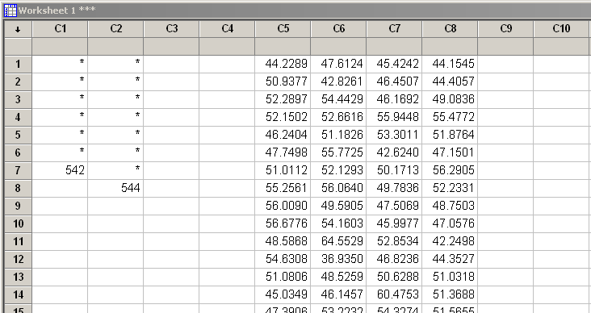

Data in column c5 – c8

Logical expressions

Logical expressions are extremely efficient in manipulating the data. They take a while to master but are then easy to use. The main feature is that the logical expression within the brackets, more or less complicated, becomes either 0 (if it is false) or 1 (if it is true). This can then be used further:

A simple example

random 20 c1; # Creates integers randomly in the
integer 11 15. # range 11 to 15.

Let c3 = (c1 = 13) # Puts a '1' in c3 if the simulated value in c1 equals 13.

let k1 = 3.5 # Stores 3.5 in k1.
Let c5 = c1 + (c1 = 13)*k1 # Adds k1 to c1 when c1 = 13. Result in c5.

let k2 = 4.1 # Stores 4.1 in k2.
Let c7 = (c1 = 13)*k1 + (c1 ne 13)*k2 # Makes c7 either 3.5 or 4.1.

Comment. Column c1 contains random data and c3, c5, and c7 have been manipulated by the help of simple logical expressions.

A more complicated example. Here the proportion within ±1 standard deviation in a normal distribution is estimated (run %NormArea for more information):

Let k1 = 10000 # Number of simulated values.
Let k2 = 1 # Column number for storage.

Random k1 ck2 # k1 values from N(0, 1).

name k3 'Proportion within 1 sigma =' # Names the proportion k3.
Let k3 = sum(ck2 > -1 and ck2 < 1)/n(ck2) # The wanted proportion.
Print k3 # Prints the result.

Further use of logical expressions
This exercise shows how a logical expression can be used in order to stratify a set of data. Column c4 contains the integers 1-3 and is used to give certain points a certain colour. Note also how the logical expression has been divided into several rows using the ’&’-symbol. In this way it is easier to create and to check the command.

Part 1 (creating concentric areas with different colours in the subsequent plot)

Rand 20000 c1 c2 # Simulates 20000 data from N(0, 1).
Let c3 = sqrt(c1**2 + c2**2) # Calculates a radius.

Let c4 = (0<c3 and c3<1)*1 & # A logical expression divided into
+ (1<c3 and c3<2)*2 & # several rows for better reading.
+ (2<c3)*3

plot c1*c2; # Plots c1 (Y) against c2 (X).
data 0 1 0 1; # Data uses the whole window.
symb; #
color c4; # Symbol colour according to c4.
scale 1; # The X-axis.
max 4; # Maximum for axis 1 (X).
min -4; # Minimum for axis 1 (X).
scale 2; # The Y-axis.
max 4; # Maximum for axis 2 (Y).
min -4. # Minimum for axis 2 (Y).

Part 2 (replace c4 in 'Part 1' by the following commands an rerun the plot commands)

Let c4 = (0.0<c3 and c3<0.5)*1 &
+ (0.5<c3 and c3<1.0)*2 &
+ (1.0<c3 and c3<1.5)*3 &
+ (1.5<c3 and c3<2.0)*4 &
+ (2.0<c3 and c3<2.5)*5 &
+ (2.5<c3 and c3<3.0)*6

Comment. This gives some more concentric circles with more colours.

